Energize Delaware

Home Performance with ENERGY STAR® Participating Contractor Operations Manual

Version 2
2019

PREPARED BY:
Franklin Energy Services, LLC 23 Copper Dr., Suite 3
Newport, DE 19804

Contractor Agreement
By signing this Agreement, Participating Contractor’s representative is certifying that Participating Contractor has read, understood and agreed to all the definitions, terms and conditions that are part of this Contractor Operations Manual.
Contractor Representative Printed Name:
Contractor Signature: | Date:

Table of Contents

Contractor Operations Manual Purpose & Maintenance 5
Program Contacts 5
Program Effective Dates 6
Program Overview 6
Home Performance with ENERGY STAR Program (HPwES) 7
Assisted Home Performance with ENERGY STAR Program (AHPwES) 7
Downtown Development District Program (DDD) 8
Program Objectives 8
Program Roles and Responsibilities 9
Program Sponsor 9
Program Implementer 9
Program Participant 9
Participating Contractor 9
Program Eligibility 10
Interested Participant Program Eligibility 10
HPwES Assessment and Installation Program Participation Eligibility 10
Assisted HPwES Assessment and Installation Program Participation Eligibility 10
Downtown Development Districts Participation Eligibility 11
Limits on Eligibility and Participation 11
Participant Acquisition and Enrollment 12
Participant Acquisition 12
Participant Information Verification 12
Program Fee Schedule 12
Program Eligible Measures and Rebate Amounts 13
Prescriptive Measure Table 13
Assessments/Diagnostic Tests Measure Table 14
Measure Standards: DIMs 15
Measure Standards: Rebate Measures 15
Overview 15
Gas Leak Detectors 16
Carbon Monoxide Detectors 16
Unvented Heaters 16
Weatherization Measures 16
HVAC & Hot Water Heater Measures 17
Contractor Participation 19
Contractor Eligibility & Enrollment 19
Contractor Onboarding 19
Contractor Outreach 19
Contractor Meetings 20
Best Practices Working Group (BPWG) 20
BPWG Working Group Representation Summary 20
Contractor Scorecard 20
Program Sequence of Events (Program Process Flows) 21
Step 1: Participant Enrollment 21
Step 2: Participant Enrollment Approval 21
Step 3: Comprehensive Energy Assessment (CEA) 22
Step 4: CEA Customer Report Delivery 25
Step 5: Work Scope Proposal and Rebate Reservation 25
Step 6: Installation of Measures 25
Step 7: Final Documentation Submission (Web Submitted) 26
Step 8: Program Verification 27
Step 9: Program Approval and Payment 27
Emergency Situations 28
Systems of Record 28
NGAGE 28
OptiMiser 30
Workflow Definitions 30
Direct Install/Assessment Project 30
Marketing & Communications 31
Program Marketing Plan 31
Customer Education Materials 31
Energize Delaware Logo Use Guidelines 32
Inspections and Field Quality Inspection 32
Field Quality Inspection (FQIs) 32
Inspection Results and Resolution Procedure 34
Pass/Fail Definitions and Criteria 34
Contractor Disciplinary Procedures 35
Safety & Risk Management 35
Adherence & Reporting Protocols 35
General HPwES Safety 35
Hazardous Substances/Materials 36
Combustion Safety (Gas Leaks / CO /CAZ) 36
Safety & Risk Management Best Practices 37
Broken Bulb Extraction – Safety and Removal Process 37
Clean-Up Procedure: Broken LEDs and Incandescent Bulbs 38
Loose Fixture Identification Procedure 38
Clean Up Procedure: Mercury in Thermostats 39
Mercury Recycling and Handling Procedure – Thermostats 40

Participating Contractor Operations Manual Purpose & Maintenance

The purpose of this document is to provide supplemental guidance and a consistent reference for contractors who are approved to participate (referred to as “Participating Contractors”) in Energize Delaware’s Home Performance with ENERGY STAR® Program (the “HPwES Program” also “Program”).
The Program has multiple participation pathways, and each Participating Contractor will self-assign the role that best captures the level of services they intend to perform within the Program. The below descriptions highlight the three (3) core Contractor Participation roles within the Program:
- Installation-Only Participating Contractor (IPC): Participating Contractor specializes in the installation of HVAC, weatherization, lighting, electrical services or other specific services, but does not perform Comprehensive Home Energy Assessments. (never a primary contractor)
- Assessment-Only Participating Contractor (APC): Participating Contractor specializes in Comprehensive Home Energy Assessments and diagnostic testing, including Test-Out completions, but does not directly contract for the installation of HVAC, weatherization, lighting or other specific services as a company. (may be a primary contractor)
- Home Performance Contractor (HPC): Participating Contractor specializes in Comprehensive Home Energy Assessments and diagnostic testing, including Test-Out completions, and directly contracts for the installation of HVAC, weatherization, lighting or other specific services as a company. Sub-Contracting for all HVAC, weatherization, lighting or other specific installations would not qualify a Participating Contractor as an HPC. (primary contractor)
All the above will be referred to as Participating Contractors (PC) as a group. “Participating Contractor” or “Contractor” will encompass all program participants in any of the three types (APC, HPC or IPC).

Program Contacts

Main Office Address Newport Industrial Park 23 Copper Drive, Suite #3
Newport, DE 19804
Main Office Phone: 302.203.6243
Main Office Email: DelawareHP@franklinenergy.com
QC Team Email: EnergizeDEInspection@FranklinEnergy.com
Program Phone (Best for Customers): 877- 524-1339
Program Manager | Joe Gennello | 484.430.3031 x4515 | jgennello@franklinenergy.com
Outreach & Marketing Coordinator | Angie Bivens | 302.203.6243 x3101 | abivens@franklinenergy.com
Program Coordinator | Traci Evans | 302.203.6234 x4418 | tevans@franklinenergy.com
Technical Lead | Gerald Spaulding | 302.203.6243 x3015 | gspaulding@franklinenergy.com
Energy Advisor | Krist Matthew | 302.203.6243 x4424 | kmatthew@franklinenergy.com
Energy Advisor | Tyler Tallman | 302.203.6243 x3102 | ttallman@franklinenergy.com
Energy Advisor | Dan Mc Brien | 302.203.6243 x4423 | dmcbrien@franklinenergy.com

Program Effective Dates
This version Contractor Operations Manual is effective July 1, 2019 and supersedes all previous versions. The Program reserves the right to modify the program design and/or the measure mix as necessary and will adjust the Program Contractor Operations Manual at such times. Whenever changes are made to the Program, a programmatic update will be sent to all participating contractors. Additionally, the Program will make every effort to ensure ample lead time is provided to Participating Contractors to enact any necessary changes in their operations.

Program Overview

Home Performance with ENERGY STAR is a national effort by the U.S. Department of Energy (DOE) to offer a comprehensive, whole-house approach to improving the energy efficiency and comfort of homes, while helping protect the environment.

Energize Delaware delivers the Delaware HPwES program in partnership with DOE, and like the national effort, takes a whole-house approach to improving a home’s energy efficiency, comfort, durability, and safety. The Program delivers energy efficiency by offering comprehensive, diagnostic energy assessments; direct installation of energy efficient measures, and completion of recommended energy efficiency improvements to residential Participants through participating Contractors.

Energize Delaware provides the HPwES Program with financial incentives and financing to eligible Delaware participants for making program eligible recommended improvements.

The Program core provides eligible Delaware participants access to qualified vendors and installation Participating Contractors in the following (3) unique tracks:
- Home Performance with ENERGY STAR (HPwES) assessment and/or installation
- Assisted HPwES, (AHPwES) – Follows HPwES track with increased incentives
- Downtown Development Districts (DDD) – Follows the AHPwES track

Home Performance with ENERGY STAR Program (HPwES)
The Home Performance with Energy Star (HPwES) Program provides a platform for Delawareans to improve their household energy efficiency, healthiness and safety through comprehensive, diagnostic energy assessments; a network of Participating Contractors to perform assessments; and, building shell and/or HVAC upgrades.
The HPwES track consists of a comprehensive home energy assessment (“assessment”) and energy efficiency upgrades, which are offered at significantly reduced costs through rebates and financing.
HPwES Assessments and Projects may only be delivered by Participating Contractors (PCs). Participating Contractors are defined as contractors that have submitted a trade ally application to the Program, provided all the necessary documentation and been accepted into the Program. To qualify for incentives, customers must use a participating contractor to initiate their application and/or for the submittal of work completion documentation.

Assisted Home Performance with ENERGY STAR Program (AHPwES)
The AHPwES program track is similar to the HPwES track but offers increased financial incentives for income-qualified property owners (and renters via their landlord). Below are the maximum annual income levels for AHPwES eligibility. Please note the income levels may be updated periodically as the Program progresses and the most up-to-date income levels can be found here: https://cdn2.hubspot.net/hubfs/4012693/AHP_Application_and_Conditions_2018_v10_032318.pd f?t=1529595565190

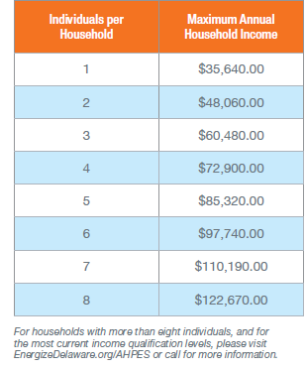
Customers must complete an application to participate. This application can be found here:https://cdn2.hubspot.net/hubfs/4012693/AHP_Application_and_Conditions_Form_Rebrand_v01_030419_FINAL.pdf

Completed applications are reviewed by the Franklin Energy team. AHPwES Assessments may be delivered by a Participating Contractor or by Franklin Energy Services staff. Energy efficiency upgrades will be delivered by a Participating Contractor.

Downtown Development District Program (DDD)
The DDD program offers the benefits of the HPwES and AHPwES program tracks to eligible mixed-use buildings and residential buildings within specific downtown/urban geographic areas.
Participation in this program is limited to mixed use properties, with residential units and commercial space of 2,500 sq. ft. or less.
DDD HPwES Assessments may be delivered by a Participating Contractor or by Franklin Energy Services staff. Energy efficiency upgrades will be delivered by a Participating Contractor.
For each of the three program tracks
Energize Delaware provides:
- Payment to Contractor for each eligible assessment
- Payment to Contractor for eligible and approved installation of direct install measures
- Interested Participant rebates for eligible and approved installation measures
- Access for qualifying homeowners to low-interest loans for energy saving improvements, details of which can be found here: https://www.energizedelaware.org/home-energy-loans

Program Objectives

- Serve Delaware residents and help them understand how to use energy more efficiently.
- Serve Delaware residents and help them make energy efficient upgrades in their home with access to no cost upgrades, rebates, and loan financing.
- Achieve cost effective energy savings by working with Participating Contractors.
- Support Delaware businesses through job creation opportunities and provide training for Participating Contractors to enhance capabilities of providing home energy efficiency services in Delaware.
- Develop educational and supporting services for customers and participating contractors to promote the implementation of energy efficiency improvements.
- Support and encourage Delaware residents and businesses to take actions that improve the environment.

Program Roles and Responsibilities

Program Sponsor
Energize Delaware - Delaware Sustainable Energy Utility (DESEU)
- Provide the customer incentives for the program.
- List Participating Contractors on the Energize Delaware website.
- Oversee Franklin Energy Services, the program implementer.

Program Implementer
Franklin Energy Services (FES)
- Plan and design the Home Performance with ENERGY STAR® Programs.
- Market the program to customers and participating contractors.
- Approve customer eligibility and enrollment.
- Recruit, train and mentor participating contractors.
- Process qualifying project applications and issue routine & timely payments.
- Maintain a database of all necessary program information.
- Conduct program quality control and quality assurance activities.

Program Participant
Delaware Occupants, Residents and Homeowners
- Enroll online to have an assessment performed and MUST include utility electric account number for the premise location
- Choose a participating contractor from (or ask the Program to choose a participating contractor) from the program’s approved list to perform assessment.
- Provide the participating contractor with the necessary home information (including energy and water usage history) to properly assess savings potential.
- Choose a participating contractor from the program’s approved list to install eligible energy
efficiency measures in the home.
- Allow the Program to access the home to verify installed measures where applicable.

Participating Contractor
- Must enroll to participate and maintain required licenses, insurances, and certificates as dictated in this Program Manual under the Contractor Participation section
- Properly provide eligible services to qualified, interested Participants.
- Ensure work completed (whether through an assessment or qualifying improvements) adheres to Program rules and guidelines.
- Must participate in program sponsored trainings and workshops
- Must utilize program software

Program Eligibility

Interested Participant Program Eligibility
The Program is intended to offer occupants, residents or homeowners of Delaware (referred to as
“Participants”) an opportunity to participate through one of the four core Program tracks. Participants are defined as those who are located within the state of Delaware and the location of the premise dwelling has a residential electric and/or gas account.

HPwES Assessment and Installation Program Participation Eligibility
- 1-4-unit residential property located in Delaware
  - Townhouses and Rowhomes are eligible for the program.
    - Townhouse is defined as a single dwelling unit in a structure that extends from foundation to attic and has its own utility meters and HVAC/DHW system. There is no limit on how many rowhomes can be connected to one another.
  - Additions to the structure, and equipment to heat/cool the new space, are not eligible for program rebates. Any additional building footprint that would add square footage to the conditioned space, that is not already heated/cooled, would not qualify for the HPwES program.
- The interested Participant owns the home, or rents and has a signed landlord consent form for the installation of energy improvement upgrades.

Assisted HPwES Assessment and Installation Program Participation Eligibility
- Household meets income eligibility at or below levels outlined above in the Assisted Home Performance with ENERGY STAR Program (AHPwES) Program Description.
  - Interested Participants must complete and sign an income verification form verifying their eligibility under the program guidelines for income qualification.
  - Prospective participants, or applicants, will be asked to provide a record of all household occupants, their monthly or annual income, and to sign an Authorization, Understanding and Agreement statement.
  - Participants must have their eligibility confirmed by the Program through a simplified income verification process prior to having work installed.
- 1-4-unit residential property located in Delaware
  - Townhouses and Rowhomes are eligible for the program.
    - Townhouse is defined as a single dwelling unit in a structure that extends from foundation to attic and has its own utility meters and HVAC/DHW system. There is no limit on how many rowhomes can be connected to one another.
  - Additions to the structure, and equipment to heat/cool the new space, are not eligible for program rebates. Any additional building footprint that would add square footage to the conditioned space, that is not already heated/cooled, would not qualify for the HPwES program.
- The interested Participant owns the home, or rents and has a signed landlord consent form for the installation of energy improvement upgrades.

Downtown Development Districts Participation Eligibility
- Mixed use property located in one of Delaware’s 8 Downtown Development Districts meeting the following criteria:
  - Commercial space of 2,500 sq. ft. or less.
  - Include both residential and commercial spaces
- Mixed use property restrictions:
  - Additions to the structure, and equipment to heat/cool the new space, are not eligible for program rebates. Any additional building footprint that would add square footage to the conditioned space, that is not already heated/cooled, would not qualify for the HPwES program.
- The interested Participant owns the home, or if rents and has a signed landlord consent form for the installation of energy improvement upgrades.

Limits on Eligibility and Participation
- Rebates in the Energize Delaware program can be reserved within the NGAGE platform by either APC or IPC contractors once a comprehensive energy assessment has been performed (Rebate reservation). Trade allies must have an active account with the NGAGE platform in order to find and apply for a rebate on behalf of a customer. The following link provides a detailed process of how to effectively find and apply for a rebate within the NGAGE system.
    - https://efficiencynavigator.blob.core.windows.net/documentlibrary/LIB_TA_USER_GUIDE_0_0_0_e1f75302a7b04e31b21e4ceaeaaf58c0.docx
  - Rebate reservations and amounts are good for 90 days from the time the reservation is approved, unless otherwise noted by the Program. After 90 days (unless otherwise noted), the contractor must submit for a new rebate reservation; the project will be subject to any changes in the program and rebate amount changes made since the previous reservation. For more information see Step 5: Work Scope Proposal and Rebate Reservation later in this document.
- The Program understands Participants may not be in an immediate position to move forward with work installation recommendations. As such, assessment recommendations can be completed within four (4) years of the assessment date and still be eligible for incentives.
  - During the four-year timeframe, re-entry for participants (to access rebate incentives) is dependent upon the amount and funding availability during the installation time of the measure or measures. The new project will be subject to any changes in the program at the time of the reservation. No new assessment fees will be paid by the program within this period, even in cases where a new contractor proposes to do a new assessment.
  - After four years, Participants will need to have a new assessment and will be responsible for the full assessment fee at a market rate determined between the Assessment Company and Participant. Participants who receive a second assessment (following the four-year period) are not eligible for discounts on the Assessment, nor Program provided DIMs.

Participant Acquisition and Enrollment

Participant Acquisition
A key component of the Programs is working through a Participating Contractor for participant participation. This may be accomplished by typical and accepted marketing efforts such as print, social media, word of mouth, etc. Interested participants who contact the program may be provided with Participating Contractor names or assigned to a Participating Contractor.

The Participating Contractor will need to gather the appropriate information to confirm the house meets the participation requirements of the program (see eligibility criteria above). In the case a home does not qualify, both the interested Participant and Participating Contractor will be notified.

Participant Information Verification
If an interested Participant’s web submission for the program does not provide
adequate information to the Program, the Franklin Energy Services team will reach out for clarification to the Participating Contractor noted in the web submission. If no contractor is noted in the web submission, the Program will reach out directly to the interested Participant. The Program reserves the right to request a copy of the electric utility bill to verify account number and address information.

Program Fee Schedule

The Program Comprehensive Home Performance Assessment Fee Schedule is as follows. Please note, the Program reserves the right to change the Fee Schedule without notice.
- Home Performance with ENERGY STAR: 25% of the assessment cost up to $100. The Program will reimburse 75% of assessment cost up to $300*
- Assisted Home Performance with ENERGY STAR & Downtown Development District: 25% of the assessment cost up to $50. The Program will reimburse 75% of assessment cost up to
$350*
*The Participating Contractor has the option to charge the Participant more than $100 for homes greater than 3,000 square feet and/or homes with multiple CAZ areas as long as the customer is advised in advance and approves the added cost.

Program Eligible Measures and Rebate Amounts

Prescriptive Measure Table
The Program provides prescriptive rebates for reserved, eligible projects that have completed a comprehensive Home Performance Assessment. The list of eligible measures and rebate amounts is as follows. Please note, the Program reserves the right to change the list of eligible measures and/or rebate amounts without notice.
Please check the website for the most current list of rebate incentive levels here: https://www.deseuhp.org/contractor-incentives

Measure | HPwES | AHPwES & DDD
Assessment Measures
Assessment Customer Incentive | 75% up to $300 | 75% up to $350
Customer Co-Pay for Assessment | $ 100 | $ 50
Weatherization Measures
Air Sealing 20% Improvement | $ 700 | $ 800
Air Sealing 30% Improvement | $ 950 | $1,150
Air Sealing 40% Improvement | $ 1,100 | $1,350
Duct Sealing 20% Improvement | $ 500 | $ 600
Add R-19 Attic Insulation | $ 900 | $ 1,100
Add R-30 Attic Insulation | $ 1,000 | $ 1,200
Knee Walls | $300 | $ 500
Rim Joist | $ 150 | $ 200
Floor/Crawlspace Insulation | $ 600 | $ 800
Wall Insulation (min 50% of walls) | $ 1,600 | $ 2,100
HVAC and Water Heating (Measures)
Heat Pumps Tier 1 (=>16 SEER and =>12.5 EER and =>8.5 HSPF or =>2.5 COP) | $ 600 | $ 900
Heat Pumps Tier 2 (=>17 SEER and =>12.5 EER and =>9.0 HSPF or =>2.6 COP) | $ 800 | $ 1,200
**Mini-Split HP (=>17 SEER and =>12.5 EER and => 9.0 HSPF or =>2.6 COP)** | $ 400 | $ 900
**Mini-Split HP (=>21 SEER and =>12.5 EER and => 10.0 HSPF or =>2.9 COP)** | $ 600 | $ 1,000
CAC Tier 1 (=>16 SEER and =>12.5 EER) | $ 500 | $ 900
CAC Tier 2 (=>17 SEER and =>12.5 EER) | $ 650 | $ 1,000
Furnace Tier 1 (94+AFUE w/ECM) | $ 500 | $ 900
Furnace Tier 2 (96+AFUE w/ECM) | $ 650 | $ 1,000
*Furnace (oil fired 85+ AFUE)* | $500 | $850
Boiler (85+AFUE) | $ 650 | $ 1,000
Boiler (90+AFUE) | $ 800 | $ 1,100
Heat Pump Water Heater | $ 750 | $ 900
Tankless Water Heater (Gas/Propane) | $ 600 | $ 800
Smart Thermostat (must be ENERGY STAR) | $ 150 | $ 200
Direct Vent LP/NG Water Heater (≤55 gallons: EF ≥ 0.67 & UEF ≥ 0.64 / >55  gallons: EF ≥ 0.67 & UEF ≥ 0.85) | $ 100 | $ 150
Condensing Boiler with On-Demand Hot Water (90+ AFUE) | $ 1,000 | $ 1,200
Mechanical Ventilation Equipment (ERV HRV Continuous Exhaust) | $ 300 | $ 500
Hybrid Heat Pump & Furnace System Tier 1 (>16 SEER & > 12.5 EER & 8.5 HSPF or >2.5 COP) and 94+ AFUE w/ECM | $ 1,000 | $ 1,200
Hybrid Heat Pump & Furnace System Tier 1 (>16 SEER & > 12.5 EER & 9 HSPF or >2.6 COP) and 96+ AFUE w/ECM | $ 1,300 | $ 1,500
**Mini Split rebates are capped at $3000/$4,000 per project**, *Requires documentation - natural gas not a viable option*

Assessments/Diagnostic Tests Measure Table
The Program provides reimbursement to Participating Contractors for the installation of Program approved Direct Install Measures (DIMs) that are installed at the time of the assessment. DIMs are offered to Participants at no additional cost and provide an initial energy savings opportunity as an incentive to continue with deeper savings recommended in the assessment report. The Participant may select any combination of Program-approved Direct Install Measures at no cost up to $200. The Participating Contractor is required to install DIMs in the home to ensure achievement of estimated energy savings (up to the established total incentive cap of $200). Contractors may exceed the total incentive cap but will only be reimbursed by the Program for amounts up to the maximum incentive value.
The list of eligible DIMs is as follows. Please note, the Program reserves the right to change the list of eligible DIMs, the total DIM incentive cap, and/or individual DIM amounts without notice.
Please check the website for the most current list of DIM incentive rates for contractors here (Appendix B): http://www.deseuhp.org/participating-contractor-resources

Assessments | Pricing Fee
HPwES Assessments | 75% up to $300
HPwES Customer Co-Pay for Assessment | $100
AHPwES & DDD Assessments | 75% up to $350
AHPwES & DDD Customer Co-Pay for Assessment | $50
Direct Install Measures | (100% up to $200 Cap)
LED 6W (A-Type)- 40W Equivalent | $ 8.00
LED 9W (A-Type) - 60W Equivalent | $ 8.00
LED 11W (A-Type) - 75W Equivalent | $ 8.00
LED 15W (A-Type) - 100W Equivalent | $ 8.00
LED 6W Globe - 40W Equivalent | $ 8.00
LED 5W Candelabra - 40W Equivalent | $ 8.00
LED 11W Flood - 65W Equivalent | $ 8.00
Outdoor LED 9W -60W Equivalent | $ 10.00
Outdoor LED 15W-100W Equivalent | $ 10.00
Showerheads-1.5 gpm | $ 25.00
Showerheads (Hand Held)-1.5gpm | $ 25.00
Thermostatic Restrictor Shower Valve | $ 25.00
Aerators-Kitchen-1.5 gpm | $ 8.00
Aerators-Bathroom-1.0 gpm | $ 8.00
Pipe Wrap (per foot, 6’ max, hot only) | $ 4.00

Measure Standards: DIMs

Contractors are expected to install DIMs to the standards listed below during an assessment. Any measure that is not installed will not qualify for reimbursement to a Participating Contractor and may preclude the reimbursement for any DIMs to the Participating Contractor for that project. In such instances, a failure notification will be sent to the Participating Contractor as per the QC Resolution Process.
- LEDs: LED lamps must replace incandescent or halogen lamps. LED lamps may not replace CFL lamps.
- Pipe Wrap: 4' linear feet max and installed only the outlet side (hot only) and contractors are not to install within 6” of an active flue.
- Aerators, Showerheads and Thermostatic Restrictor Shower Valves: Installed to industry best practices.
If no DIMs are installed during an assessment it must be documented on the comprehensive energy assessment report. A short explanation will suffice for ex. In the DIMs section of the report a contractor can state “client home has all LED, CFL, or combination of LEDs/CFLs in majority of house.

Measure Standards: Rebate Measures

Overview
Contractors are expected to install all materials and equipment that are being submitted for a Program qualifying rebate to the Program standards and manufacturer specifications.
Below is an overview of the standards all projects must follow in Energize Delaware’s HPwES
Program.

The Program will follow BPI 1200 and Technical Standards unless specifically stated otherwise
  - Compliance with the Building Airflow Standard (BAS) located in the Technical Standards will be required for all projects under the Energize Delaware HPwES Program.

Minimum insulation levels required in an attic to receive rebates for HVAC equipment:
- The minimum insulation levels required in an attic is anything less than a stated R-19. The “stated R-19 “is the intended installed R-value in an attic.
- When insulation is below R19 the program will require additional insulation in order to receive rebates on and HVAC equipment.
- Air Sealing must accompany insulation. That is, anytime insulation is offered, air sealing must be accompanied and completed (or already be present and completed) – even if the air sealing will not qualify for a prescriptive program rebate.

Ventilation Requirements
- Clothes Dryers – Must exhaust to outside
  - Unvented – needs be vented with hard pipe or flex insulated hose: R4
  - If vinyl flex is existing (and is vented to the outside), contractor should recommend replacement (but is not required to replace).
  - Any newly installed exhaust ducts in unconditioned spaces must be insulated to R7 (IECC 2012).
- Bath Fans– Must exhaust to the outside
  - Unvented – needs be vented with hard pipe or flex insulated hose: R4
  - If vinyl flex is existing (and is vented to the outside), contractor should recommend replacement (but is not required to replace).
  - Any newly installed exhaust ducts in unconditioned spaces must be insulated to R7 (IECC 2012).
- Gas Kitchen (Range/Oven) Fans
  - If a kitchen fan is vented to unconditioned space (i.e. attic or basement), it needs to be vented to the outside
  - If Kitchen contains a recirculating fan, then contractor should recommend replacement (but not required to replace)
  - If the contractor is to install a new Kitchen fan, then it must comply with the Building Airflow Standard.

Gas Leak Detectors
Participating Contractors must have a gas leak detector that can provide a digital display of percentage of Lower Explosive Limit (LEL) and/or provide an alarm when detecting combustible gas concentrations exceeding 10% Lower Explosive Limit (LEL).

Carbon Monoxide Detectors
The Program will more narrowly follow NFPA Standards and expects when there is an attached garage and/or combustion appliance, that one carbon monoxide detector is centrally located on each floor, and centrally located outside of each separate sleeping area, in the immediate vicinity of the bedrooms.
For all units, contractors should ensure units are operable.
For existing units already in the house, contractors should review the age of the unit and take the appropriate step. The Program encourages contractors to check the age of the unit and advise the Participant to replace units that are nearing their rated shelf life.

Unvented Heaters
The Program will follow BPI 1200: contractors should recommend the removal of unvented heaters (but are not expected to disconnect any units). To support contractors in the conversation of recommending removal, the Program will create a removal recommendation notification for contractors to provide Participants.

Weatherization Measures

Air Sealing

Air sealing projects in the Program will be directed at the thermal & pressure boundaries of the building. All attached areas of the building must be considered when addressing the entirety of the thermal & pressure boundaries. Zonal readings may be requested by the Program for verification purposes.
- Air sealing always needs to accompany insulation. That is, when insulation is offered, the area must be air sealed. All thermal bypasses should be sealed prior to insulation regardless of reduction level.

Attic Insulation
- Attic must be air sealed prior to or as part of insulating the attic
- Attic must be insulated to one of the following levels:
  - Open attic insulated to at least R49
  - Priority measure if R-19 or less of material exists
  - Enclosed cavities filled to capacity with dense-pack insulation
  - Spray foam is an eligible measure and must be installed to manufacturer’s specs
(when applicable, it should include code-approved fire protection)
  - **Photo evidence must be recorded if the attic space is intended to be permanently (or semi-permanently) sealed off**

Wall Insulation (50%)
- Wall Insulation must be insulated to one of the following levels:
  - Enclosed cavities filled to capacity with dense-pack insulation
  - Open cavities filled to capacity with low density spray foam
  - Wall Insulation: 50% of the total sq. ft. must be included
  - Voids should be less than 5% of total treated surface area

Floor / Crawlspace Insulation
- Basement upgraded by insulating:
  - Basement or crawlspace ceiling with R-30 insulation or minimum 2” of
foam
  - Foundation walls must be insulated to R-13 or treated with 2” foam board or spray foam for continuous applications
  - Ceiling and foundation walls are mutually exclusive. Project must have one pressure and thermal boundary that is aligned.
  - Floor insulation measure can be used for treating garage ceilings where the garage is fully unconditioned with conditioned space above.

HVAC & Hot Water Heater Measures
- Any projects that has space conditioning rebates reserved must have a minimum of R-19 insulation already existing in the attic. This must be prior to processing and approval of any rebates for space conditioning appliances (Space conditioning includes A/C units, Mini split systems, Heat Pumps, Furnaces and Boiler Systems). If this condition is not met, then the project work scope must include the installation and execution of insulation.
  - In cases where insulation is needed in a home in order to process the rebates for space conditioning, it must be brought up to a minimum R-value of R-30 or greater.
  - In cases where an attic does not meet the minimum insulation requirement and adding additional insulation is not practical, the CEA report must clearly document a detailed and logical reason for skipping this measure. These cases will be reviewed by two or more Franklin Energy technical staff for approval of a waiver. The waiver will be documented with the file and shared with the appropriate parties.
- All projects must be installed to the Program standards and manufacturer specifications.
- HVAC equipment must be installed to provide conditioning (heating and/or cooling) in a space that is already conditioned and within the thermal envelope. Portable space conditioning appliances do not qualify for replacement. Areas that are outside of the thermal envelope – and not already conditioned – are not permitted.
- HVAC Systems that are not intended to be used as the primary heating source do not qualify for program incentives.
- The number of multi-split rebates available on a project are based on the number of condensers (the energy saving component is the compressor). **Mini-Split rebates per project is capped at $3000/$4,000, once that limit is met no further rebates for mini-split systems can be reserved. **
- The number of smart thermostat rebates available on a project are based on the number of systems, not the number of zones. Multiple zone systems will only qualify for one smart thermostat.
Contractor Participation

Contractor Eligibility & Enrollment
A key goal of the Home Performance with ENERGY STAR Program is to develop a network of qualified Participating Contractors to enhance local business development, employment of Delawareans and heightened customer satisfaction. Contractors are responsible for properly installing qualifying improvements and providing eligible services to qualified Delaware interested Participants. To become a Participating Contractor in Energize Delaware’s HPwES Program (which is inclusive of offering services the HPwES, AHPwES and DDD tracks), contractors must sign, submit, and adhere to the Contractor Participation Agreement (CPA) form in addition to signing an acknowledgement of receipt of this Contractor Operations Manual (COM).

Prospective contractors must register to participate at tradeally.efficiencynavigator.com. Once registered, prospective contractors will be provided with a secure login to the NGAGE portal and must complete and submit the below items to the Program Implementer. Once documentation is confirmed, access to OptiMiser will be granted for primary contractors also designated as APC and HPC pathway contractors. IPCs will need access to NGAGE but will not need access to OptiMiser.

- A Contractor Participation Agreement, indicating Contractor Role (IPC, APC, HPC)
- Signature of acknowledgement regarding this Contractor Operations Manual
- Company Tax ID number
- An IRS W-9 Form
- A Certificate of Insurance (COI), including Worker’s Compensation coverage, verifying the
following commercial general liability insurance minimums:
  - $500,000 per occurrence
  - $1,000,000 general aggregate
  - $1,000,000 aggregate for products and completed operations
- An active Delaware Business License from the Delaware Department of Finance
- Any Certifications or Licenses that are a requirement of the Company’s trade
- BPI Certifications (Building Analyst and Envelope Professional), if the Company is an APC or HPC as self-identified in the CPA.

Contractor Onboarding
Prospective contractors entering the Energize Delaware Program will go through an onboarding training session designed to bring them up to speed and educate them on program requirements and responsibilities. This training will be hosted by the Franklin Energy Services team on a routine basis. Training will focus on specific categories:
- Program software registration and use
- Paperwork submission requirements
- Energize Delaware Field Quality Inspection processes and expectations
- Program and participation timelines
- InClime Residential Loans and processes

Contractor Outreach
Program efforts will be made to continually engage Participating Contractors and support their efforts in taking a whole-house approach to improving a home’s comfort, energy efficiency, and safety.

Contractor Meetings
Upon request of the DESEU and/or Franklin Energy Services, Participating Contractor will be requested to attend meetings for program updates and additional trainings. The Program will work to ensure contractors are given notice in advance.

Best Practices Working Group (BPWG)
The HPwES Program has established a Best Practices Working Group, which will consist of representation from the Participating Contractors, the DESEU, the DESEU Board (as interested), and Franklin Energy Services. The Best Practices Working Group will meet, at minimum, on a quarterly basis.
Participating Contractors representatives will be elected annually by their peers. Two Participating Contractors will be selected from each core role group (APC, HPC, IPC). Where two contractors of each category have not applied, the top two in the other categories will be elected, then the applicant in the remaining category will be auto elected, or the next one or two highest vote recipients of any category.

BPWG Working Group Representation Summary
Six (6) Participating Contractors:
- 2 Assessment-Only Participating Contractors (APC)
- 2 Home Performance Contractors (HPC)
- 2 Installation-Only Participating Contractors (IPC) Program Representation:
- DESEU Representative(s)
- DESEU Board Member(s) (as interested)
- Franklin Representative(s)

Contractor Scorecard
The Scorecard is intended to provide feedback to potential customers and contractors regarding the quality and timeliness of projects submitted to the Program. The Scorecard will be posted on the Program website and will be updated on a quarterly basis. New contractors will be scored once they have completed at least 10 inspections per APC/HPC and 5 inspections per IPC.

Contractors in the Energize Delaware Program will be scored by the administrator based on the following parameters:
- Conversion rate – (% of Weatherization (Wx) jobs)
- Failure rate - (% of inspection failures)
- Complaint rate
- Resolution days – (number of days to resolve inspection failures)
- Documentation of paperwork
- Customer feedback

Program Sequence of Events (Program Process Flows)

The following process flow is expected for all projects submitted through the HPwES, AHPwES and DDD tracks. Please note that it is essential to follow these flows to ensure timely rebate processing and payment.

Step 1: Participant Enrollment
To request an assessment, each interested Participant must fill out the online interested Participant intake form. This is located on the DESEU website here: http://www.deseuhp.org/getstarted.

Please note, for interested Participants who do not have internet access, they should call 1-877- 524-1339, and the Program will provide assistance to fill out the online interested Participant intake form on the interested Participant’s behalf.

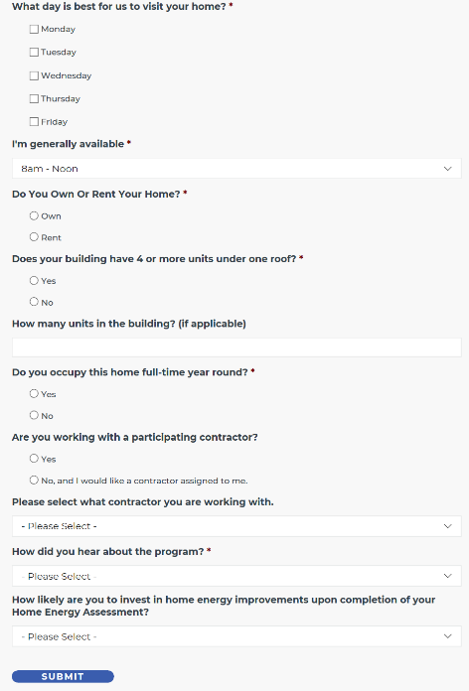
Below are screenshots that depict what the intake form requires from the interested Participant.
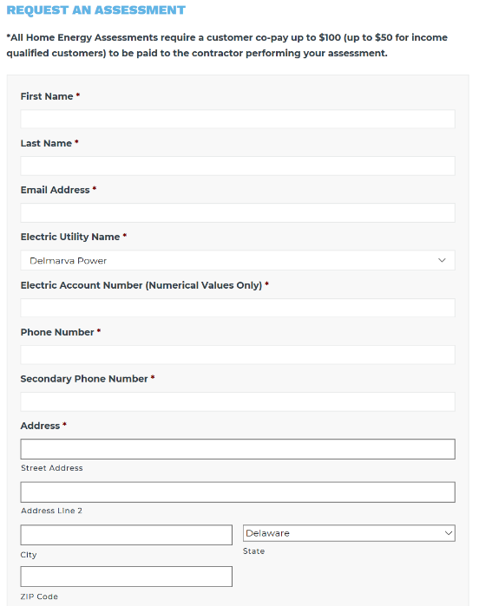

Step 2: Participant Enrollment Approval
The Program will aim to approve Assessment intakes in 24 business hours or less. Confirmation of the assessment will be provided to the Participating Contractor and Participant via email message and in the Participating Contractor’s OptiMiser work queue.

For Participants who indicate they are not working with a Participating Contractor and would like to have one assigned, the Program will provide the Participant with a Participating Contractor who is in good standing with the program. This allocation will be evenly distributed within each territory to contractors in good standing until the program scoring mechanism is finalized. At that time where the scoring mechanism is vetted, approved and implemented, a merit- based allocation of leads will be enforced, where better performing contractors will get a higher percentage of unassigned leads.

When assigned a lead, the Participating Contractor is asked to reach out to the interested Participant to schedule an assessment within 3 business days or less. For unresponsive leads, the Program asks Participating Contractors to make at least 3 attempts (via phone and/or email) with the interested Participant to schedule the assessment. After the 3rd attempt, the contractor should notify the Program that it can close out the assessment request in the Program’s system of record.

Step 3: Comprehensive Energy Assessment (CEA)
Prior to scheduling the assessment, the Participating Contractor should confirm the company has received the online project via email communication and OptiMiser work queue.
The Comprehensive Energy Assessment (CEA) data will need to be entered into the OptiMiser tool by the primary contractor for the project. The CEA shall include, at a minimum, the following elements:

Assessment Terms and Conditions: The primary contractor shall present the OptiMiser Assessment Terms and Conditions to the homeowner for review either in a digital format for their digital signature or as a hard copy which can be loaded into the OptiMiser upload file for transmission with assessment data. A contractor will not proceed with an assessment or the installation of Direct Install Measures until the Participant has agreed to, and signed, the OptiMiser Assessment Terms and Conditions.

- Explain the program and assessment process
- Explanation of direct installed measures (where installed in the HPwES track)
- Educate interested Participants of other applicable energy efficiency programs that are available and increase their participation in other DESEU programs
- Disclosure of any additional cost associated with final test out inspection at the time of the initial comprehensive energy assessment.

Participant Interview: At some point before, during, or after the physical inspection of the property, the Participating Contractor shall interview one of the primary occupants of the home to identify any specific issues the interested Participant is seeking to address through the HPwES program and typical occupant behavioral patterns as they relate to the performance of the home.

Review of Energy Bills: The Participating Contractor shall also request historical energy (electric and gas – and when appropriate, water) bill data from the interested Participant as part of the CEA. This usage may be obtained directly from the interested Participant or via the Authorization to Release Information Form. A review of energy consumption data is critical to determining how the Participant uses energy; not having this information limits the effectiveness of the CEA. When historical fuel-use data is available, the Participating Contractor shall review that data to identify patterns that will inform the prioritization of recommended measures and confirm that projected energy savings estimates are realistic. At a minimum, the Participating Contractor shall review interested Participant-reported annual or monthly energy costs and use it as a benchmark against estimated cost-savings predictions.

Visual Home Survey and Inspection: A visual inspection shall be completed of the home’s exterior, interior, thermal envelope, and all mechanical systems (including equipment, distribution systems, and controls). Relevant items should be recorded in the data collection process (and either during or after the assessment, into OptiMiser). Any health or safety hazard should be identified, and appropriate actions and/or recommendations performed prior to installing Program measures.

Diagnostic Tests: Instrumented diagnostic testing shall be completed as part of the CEA process as required to effectively assess the home’s energy performance, produce energy savings estimates, and develop an accurate list of recommended improvement measures. This should include:
- Perform Blower Door air leakage testing,
- Perform Duct leakage testing when applicable
- Perform calculations for Ventilation compliance with the Building Airflow Standard
- Perform infrared picture capture (and analysis) when appropriate
- Perform BPI combustion safety test and follow health and safety guidelines

Data Collection: Observed and measured data shall be inclusive of the following elements:
- The home’s physical geometry, features, and measurements. This should be inclusive of the siding, roofing, attic venting, foundation type, shading on property, windows, window coatings, doors, external HVAC components, and building orientation.
- The identification and performance data for heating, cooling, ventilation, and domestic hot water equipment and systems. Performance data to include fuel type, efficiency rating, age of equipment, model number and brand.
- The identification and types of lighting and major appliances, which may be used to inform interested Participants of opportunities for improvements.
- The existing type, quantity, and condition of thermal elements of the building enclosure, including component types and R values. (See charts below for insulation default values).

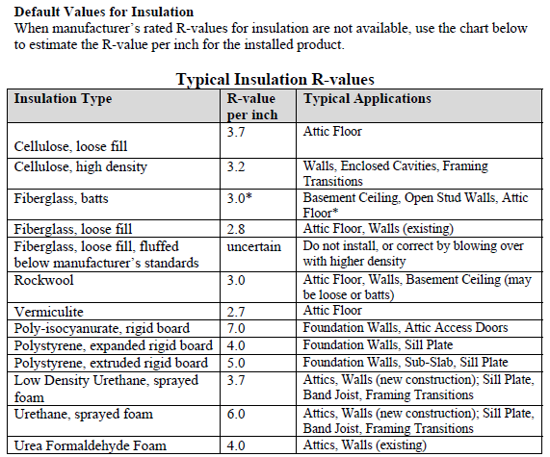

Pictures. The following pictures are suggested to be taken, retained, and made available to Program staff for field quality inspection (FQI)) or other purposes.

- Front of the house from street showing whole house (mandatory for report). The picture on the front of the CEA report must be of the actual home located at the address and not a generic template photo.
- All equipment data plates (HVAC, water heating, etc.)
- Pre- and post-monometer readings in cubic feet per minute (CFM) for ducts and air infiltration, taken side-by-side with top portion of project completion form w/address & name visible
- Pictures of any major issues, e.g., water damage, mold, air leakage, duct leakage etc.
- Pictures of proposed retrofit areas (attics, basements, HVAC equipment, DHW’s)

Combustion Appliance Safety Testing: When combustion appliances are present in the home, combustion appliance safety testing shall be completed following the BPI 1200 Standard.

Review of Overall Findings: After the assessment is complete, a general overview of findings should be discussed with the Participant. The Program highly suggests using OptiMiser during or after the assessment so that a comprehensive report can be presented to the Participant.

At this time, a list of prioritized recommended improvements (and a prediction of the improved home performance, including estimated energy savings) should be presented as a Scope of Work. Note that if insulation is required for part of an HVAC project, it should be bundled—or noted—in the list of measures to make quick reference for the Participant when selecting upgrades/measures to install.

Review of Eligible Rebates and Financing: Participating Contractors are expected to provide a prioritized Scope of Work (emailed or printed) for proposed retrofit measures that the Participant can contract improvements for.

Low Interest Loans (up to $30,000, at 5.99% APR for terms of up to 10 years for energy saving improvements) are an available resource that can be offered to clients: call (877) 453-2327 or download the SEU’s Home Energy Efficiency Loan Program Brochure. It is highly recommended that for Energize Delaware projects where participants applying for rebates to have upgrades installed and are seeking financing options, be presented with the loan options available through Energize Delaware in prioritization over other external loan options. Further, there is an incentive opportunity for contractors that recommend loans to customers that complete the loan process. Currently that incentive is $200.00.

The link to the loan program website – to apply and check/verify current terms and conditions for the loans – can be found here: http://greengrantdelaware.com/home-energy-efficiency/.

Sample Narrative for Loan Financing: There are a number of options for financing your energy efficiency project. The Program offers qualifying homeowners low-interest loans, up to $30,000, at 5.99% APR for terms of up to 10 years for energy saving improvements. If it’s convenient for you, I am happy to leave you this Loan Brochure that has additional details.

Step 4: CEA Customer Report Delivery
Participating Contractors are expected to produce and provide Participants a report on all assessment findings within 10 business days. This OptiMiser report must include the following:
- Installed DIMs
  - If no DIMs are installed in a home a brief explanation must be included in the Comprehensive Energy Assessment
- Recommended and cost-effective improvements.
- Estimated energy savings
- Documented air infiltration results in CFM

Step 5: Work Scope Proposal and Rebate Reservation
Once a Scope of Work has been contracted between an Assessment Participant and a Participating Contractor, the Participating Contractor shall submit documentation for Program review through NGAGE to reserve rebate funding (noted as Web Preapproval in NGAGE). Failure to submit correct information may result in delays in reservation approval.

Rebate reservations are good for 90 days from the time of approval, unless otherwise noted by the Program.

Participating Contractors will have 10 business days—unless otherwise noted by the Program— from the time the rebate has been reserved to submit the following documentation:
- A signed proposal/contract of the proposed measures with:
  - Cost per Measure and Total Project Cost
  - Rebate per Measure and Total Project Rebate
  - Fuel Type per Measure (Natural Gas vs Propane Gas must be distinguished)
  - Efficiency per Measure
- OptiMiser-Generated Assessment Terms and Conditions
  - The Participating Contractor is responsible for ensuring the Assessment Terms and Conditions is signed appropriately. The rebate will not be processed until the signatures are acceptable.

Step 6: Installation of Measures
The Program will aim to approve rebate reservations (Web Pre-Approval projects) in 3 business days or less. Confirmation of the rebate approval will be provided to the Participating Contractor through both NGAGE and OptiMiser. Should a contractor have an emergency requirement or requires approval faster than 3 business days, you can request an expedited review by reaching out to Franklin at any time. Following the receipt of reservation of rebates notification, installations of eligible measures and equipment may begin.

Generally, assessments and the installation of eligible measures should be scheduled as close together as possible (ideally, within a couple weeks of each other, as schedules and weather permit).

Participating Contractors will install all qualifying measures for which incentives are provided in a professional manner, consistent with industry standards and in alignment with all applicable building codes; zoning laws; local, state and federal requirements; local permitting requirements related to their trade installations, if any; and other relevant requirements. The Participating Contractor is responsible for any applicable permits as required by aforementioned codes/laws. If any health and safety issue is found at the time of installation, the project will not be considered complete until the Participating Contractor installing the measure(s) submits documentation that the proper remediation of the health and safety issue identified during the installation has been completed.

During the installation of eligible measures, the Participating Contractor shall have the Participant sign the NGAGE Installation Terms and Conditions document (note that this is separate from the Assessment Terms and Conditions), which is also generated by NGAGE.
The Participating Contractor must complete all testing required by the Test-Out Document.
Lastly, the Program advises Participating Contractors conduct their own, internal quality assurance inspections of work performed.

Step 7: Final Documentation Submission (Web Submitted)
Once the work is complete (all measures have been installed to the Participant’s satisfaction, and the test out is complete) the Participating Contractor shall submit final documentation into NGAGE for Program review to release rebate payment.

Participating Contractors will have 10 business days from the time the project is complete to submit the following documentation into NGAGE:
- A signed proposal/contract of the installed measures with:
  - Cost per Measure and Total Project Cost
  - Rebate per Measure and Total Project Rebate
  - Fuel Type per Measure (Natural Gas vs Propane Gas must be distinguished)
  - Efficiency per Measure
- OptiMiser - Assessment Report
  - The Participating Contractor is responsible for ensuring the Assessment report is loaded as part of the application. The Assessment Terms and Conditions must have been signed appropriately during the assessment phase. The rebate will not be processed until the signatures are in good order and the assessment report is loaded into NGAGE.
- The Completed and Signed Test Out Form
  - Pending further updates to OptiMiser and NGAGE, the recipient of the rebate check must be indicated on the Test Out Form.
  - The Participating Contractor is responsible for ensuring the Test Out Form is filled out and signed appropriately. The rebate will not be processed until all Test Out information and signatures are in good order.
  - Participants that receive weatherization type changes to their homes must receive a copy of the final test out document. This document must include the pre and post blower door air infiltration measurement along with the original and final R-value(s) of all insulated spaces.
- Documentation of Efficiency & Sizing
  - HVAC Equipment: all HVAC equipment must be certified by the Air-Conditioning, Heating and Refrigeration Institute (AHRI). An AHRI Certificate matching the installed HVAC equipment must be submitted.
  - Water Heating Equipment: all water heating equipment must be certified by the Air- Conditioning, Heating and Refrigeration Institute (AHRI). An AHRI Certificate matching the installed water heating equipment must be submitted.
  - Envelope Improvements: all envelope improvement measures must be accompanied by a spec sheet detailing the R value.
  - Efficiency ratings of equipment and sizing of equipment must be listed on proposals and final invoices to cross reference AHRI certificates.

Step 8: Program Verification
Once the Program receives a Web Submitted project in NGAGE, the Program will review the final documentation to ensure accuracy and approve or reject the project within 10 business days.
It is the responsibility of the Participating Contractor to ensure all information submitted is correct and accurate. If documentation is found to be inaccurate or incorrect, the rebate will not be processed until the contractor resubmits the correct information or resolves the inaccuracy.
Missing documentation and information will result in the delay of rebate processing and payment.
Prior to any payment of rebates, the Program reserves the right to verify sales transactions. A Participant’s home may also be selected for a field quality inspection (FQI) (post-installation) or service inspection by the Program. If any health and safety issue is found at the time of a post FQI by the Program, the project will not be considered complete until the Participating Contractor installing the measure(s) submits documentation that the proper remediation of the health and safety issue identified during the FQI has been completed. (SEE QUALITY CONTROL INSPECTIONS FOR ADDITIONAL DETAILS).

Where it is found that Program rules were not followed or deliberately ignored, there may be financial penalties or hold backs from the contractor to hold the Participant and Program harmless.

Step 9: Program Approval and Payment
Once the Program verifies the accuracy of the project, the Program will approve the measure(s) for rebate payment.
The rebate check will be sent to either the Participant or the Participating Contractor, as indicated by the Participant on the Test Out Form and in the NGAGE system. The Participant signed Test Out Form will take precedence over the payee listed in NGAGE should there be a discrepancy.

Please allow 4-6 weeks for payment. Again, payment processing will take longer if information is missing from the application.
For rebate approval and/or payment status please look the project up in NGAGE or call 1-877-524-1339 with any questions.

Emergency Situations
The Program will only incentivize projects that adhere to the requirements and proper order of operations in the Delaware Home Performance with ENERGY STAR Program, which are:
- An assessment is conducted prior to (or during) the finalization of any work scope.
- An assessment should never be conducted after the installation of any mechanical equipment or weatherization measures.
- Emergency Installations are not incentivized through the Program
  - In Emergency situations where an installation is necessary, a comprehensive energy assessment is still required before any installation is performed.

Systems of Record

Process / Purpose | System or Tools
Assessments & DI | OptiMiser
Incentive Applications | NGAGE
System of Record (internal) | Efficiency Manager

NGAGE
NGAGE is a web-based platform (requiring internet access) the Program will use to receive and process program rebate applications.

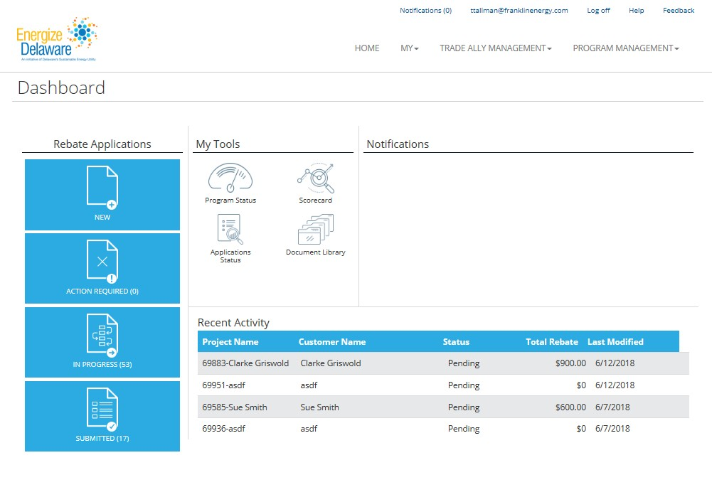

OptiMiser
OptiMiser is an HPXML compliant software the Program will use to model energy and financial savings for project assessments and installation measures.
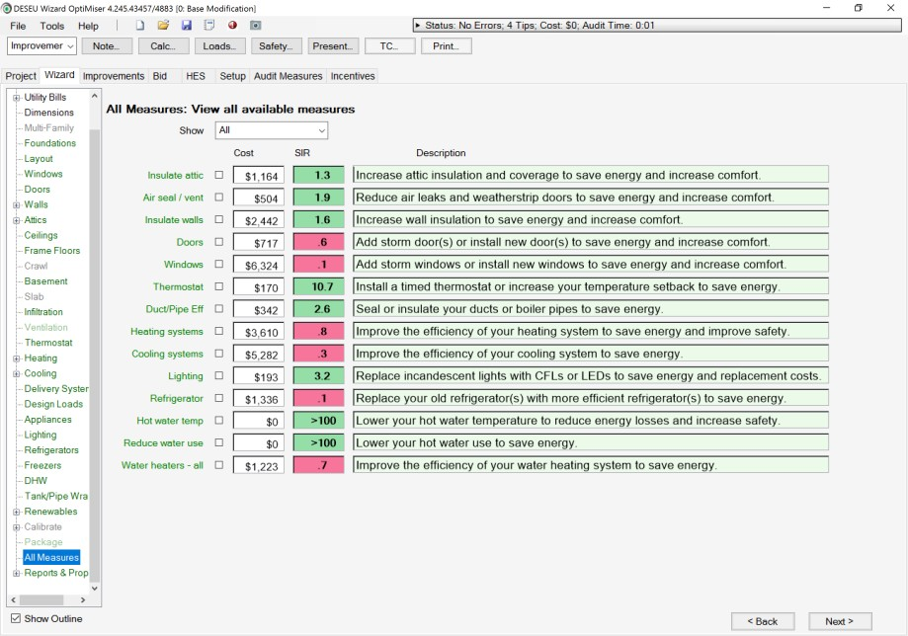

Workflow Definitions

Direct Install/Assessment Project
Status | Explanation
Survey Scheduled | Direct Installation is scheduled, project ready in OptiMiser
Work Complete | Assessment completed and submitted by Participating Contractor for Assessment and DIMs reimbursement
Incentive Authorized | Project has been reviewed and approved for payment (to the Participating Assessment Contractor)
Batched | Project is batched for payment
Paid | Check has been issued to Participating Contractor
Application Incomplete | Project is missing information
Approval Rejected | An approver has rejected the project due to errors
Cancelled | The project has been cancelled by the Participant, Contractor or Program
Rejected | The project was rejected by the program.

Payment Process for Direct Install Measures
Upload to Approval
The project is assigned to a TA, the TA completes the assessment and uploads the assessment details from Optimiser to Efficiency Manager. If no further information is needed, the project is then approved for payment. This upload to approval process is normally completed with-in 10 business days. The status changes during this part of the process begin as “Survey Scheduled” and when complete are referenced as “Work Complete”.
Approval to Invoice
During the “Incentive Authorized” status an Energize Delaware Energy Analyst will review the submittal to determine if additional information or documentation is required. Once reviewed and approved the status is changed to “Incentive Authorized”. Once approved the projects are collected on a preliminary invoice and sent for review to DESEU twice per month usually on the 15th & 30th of each month.
Invoice to Paid
Once DESEU approves of the preliminary invoice, the “Batched” projects are then sent to the accounting department. The accounting department verifies the pre-funding account to confirm that funds are sufficient and proceeds to pay the incentives to the payee of record. Payment is usually processed within 10 days. Once the payment has been processed the project status becomes “Paid”. TAs should allow 4 to 6 weeks from submittal for payments.

Prescriptive Projects

Status | Explanation
Web Pre-Approval | Pre-Application submitted through Navigator
Application Submitted | Pre-Application and all necessary documents received; Pre-inspection scheduled if required
Pre-Approval | Pre-inspection completed if required, project ready for pre-approvals
Work In-Progress | Project has been pre-approved by all required approvers; reservation letter has been sent
Web Submitted | Final Application submitted through NGAGE
Application Received | Final invoice and all necessary documents received; Post inspection scheduled if required
Work Complete | Post Inspection completed if required; project ready for final approvals.
Incentive Authorized | Project has been reviewed and approved for payment
Batched | Project is batched and sent to finance for payment
Paid | Check has been issued and mailed
Application Incomplete | Project is missing information and will arrive in “Action Required” queue
Cancelled | The project has been cancelled by the customer
Rejected | The project was rejected by the program.

Marketing & Communications

Program Marketing Plan
The Program will continue to perform general marketing and outreach efforts, direct leads to Participating Contractors as appropriate, and develop collateral to be shared with Participating Contractors.

Customer Education Materials
The following customer education materials may be distributed by contractors, available for download or request via the website, and will be distributed by Program staff at trade shows and other direct outreach events.
- Home Performance & Assisted Home Performance with ENERGY STAR brochures
- Rebate Measure Mix Tables
- ENERGY STAR brochures, including “What to Expect from Home Performance”, “Duct Sealing”, “Seal and Insulate with ENERGY STAR”, etc.
- Post-energy assessment leave-behind materials designed to keep the Participant interested in signing a contract for measures promoted under the Program
- HPwES and Energize Delaware Participating Contractor logos for advertising, marketing, and sales materials
- Other materials as the budget allows

Energize Delaware Logo Use Guidelines
As a market-based program, Energize Delaware’s Home Performance with ENERGY STAR® Program (“the Program”) welcomes and encourages Participating Contractors to promote awareness and interest of the Program and its offerings. To support this awareness and interest through contractors, Energize Delaware will make the Program name and logo available to a Participating Contractor after signing the Logo Use Guidelines Agreement Form (“Agreement Form”).

- The logo Use Guideline Agreement Form can be attained through the following link:
  - https://cdn2.hubspot.net/hubfs/4012693/Logo_Guidelines_FINAL.pdf

Inspections and Field Quality Inspection

Field Quality Inspection (FQIs)
Franklin Energy Services will maintain standards of performance by inspecting the quality of delivered services by Participating Contractors at every stage of the Program delivery. Participating Contractors may or may not be notified by the program when their work will be inspected. Findings during Field Quality Inspections will be documented and reflected on the web-based contractor scorecard.
FQIs will primarily be performed during or following the two sequences of events:
- Assessment Inspection – field visits that occur during or after the initial Home Performance with ENERGY STAR Assessment, before a scope of work is developed. These visits will primarily focus on Participating Contractor professionalism, program delivery, and sales/work scope feedback. It will also focus on the accurate count and installation of DIMs as recorded by the Participating Contractor in OptiMiser and rebate project submissions in NGAGE. The inspector may also assist the Participating Contractor with energy modeling in OptiMiser, explaining program details to the interested Participant, verifying existing conditions and equipment details, and/or clarifying next steps for program participation.
- Installation Inspection – field visits that occur after work has been completed by a Participating Contractor, to verify project accuracy. The inspector will verify the existence and condition of all rebate-eligible measures. The inspector will also conduct all applicable safety and verification testing.

For both assessment and installation inspections, the Program's inspection criteria can broadly be categorized as follows:

- FQI all incentivized measures that are being submitted through the Program
- FQI the health and safety of the home to BPI protocols
- FQI the results of all diagnostic measurements
- FQI the project to ensure the program is represented properly and professionally
- FQI the project for any missed opportunities

Inspection Results and Resolution Procedure
The Program reserves the right to notify Participants of the results on a case-by-case basis. Generally, the Program will discuss the results if there is a clear health and safety issue present (e.g. a spilling DHW system) or if the customer’s rebate will be directly impacted in not qualifying for a rebate (e.g. non-qualifying equipment was installed). In all instances in which there is an issue or failure (see definitions below) the Program will notify and work with the Participating Contractor(s). In an instance in which an issue or failure is found:
- The Participating Contractor(s) must remediate the issue and/or failure
- The Participating Contractor must submit documentation that the proper remediation issue has been completed to the FQI Team at EnergizeDEInspections@FranklinEnergy.com.
  - Any required corrective actions will need to be signed off by the Participant as being completed on the Programs FQI Failure Form before the project can be resolved. It is recommended the Participating Contractor document the corrective actions taken with photographs.
  - If re-verification of direct install measures (DIMs) reveals a reduction in savings and incentive amounts, the difference will be calculated and sent to the Participating Contractor.
  - If re-verification of a prescriptive project reveals a reduction in savings and incentive amounts, the difference will be calculated, and the project will be incentivized at the new amount. If the new amount is lower than what was previously anticipated by the Participant, the Participating Contractor may be responsible for reimbursement to the Participant for the difference between the rebate amounts.
  - The Program has the sole discretion to determine the required resolution and whether the repair is deemed to be satisfactory.

The Program reserves the right to re-inspect corrective actions meant to resolve potential health and safety issues. Where it is found that Program rules were not followed or deliberately ignored, there may be financial penalties, negative impact to the contractor score card, suspension and/or removal from the program..

Pass/Fail Definitions and Criteria
Across the five (5) broad categories of the Program's inspection criteria, there are multiple pass/fail scenarios that could result. The various “Pass” and “Fail” definitions for the Program are detailed below.

Failure – No Resolution Available
This category is for ineligible measures, measures not installed, or measures installed in a manner that disqualifies them from rebate eligibility. No rebate will be paid out for these items and no additional follow up is required.

Failure – Follow Up Required
Items in this category must be addressed and photo evidence of the resolution must be submitted to the program within a timely manner based on the severity of the issue/failure. As noted above, the Participating Contractor must submit documentation that the proper remediation issue has been completed to the FQI Team at EnergizeDEInspections@FranklinEnergy.com.

Pass – Resolved
This category is for projects after an initial finding of “Resolution Required”. No additional follow up is required for these items.

Pass – No Issues
Items in this category have met all the Program standards.

Contractor Disciplinary Procedures
Contractors are expected to maintain a high level of performance, and interested Participant satisfaction, that complies with all program terms and conditions. If a Participating Contractor is found to not be following Program rules—as set forth in the CPA and this Manual – the Program will implement corrective actions, up to and including removal from the program. Though Franklin Energy Services will review and handle issues on a case-by-case basis, some common examples of activities that will lead to disciplinary action and/or removal are (this list is not all encompassing):
- Criminal activity
- Fraudulent activity
- Gross safety violation or continued unsafe installation practices
- False representation of the Program to interested Participants
- Repeated inspection failures
- Participant complaints

Energize Delaware and Franklin Energy Services are not responsible for any costs incurred by a Participating Contractor prior to, and/or after a probation or suspension from the Program.

Safety & Risk Management

Adherence & Reporting Protocols
Any injury, illness, significant event, loss or damage occurring in an interested Participants home or on an interested Participants property must be immediately reported to the Program.

General HPwES Safety
The Program requires Participating Contractors to follow federal and state practices if a health and safety issue is found, either during the assessment, at the time of the installation of measures, or during a Test-Out for all projects. The project will not be considered complete – nor will a rebate be paid – until contractor installing the measure(s) submits documentation that the proper remediation of the health and safety issues identified have been completed.

Hazardous Substances/Materials
The Program requires Participating Contractors to follow federal and state practices when hazardous substances are found. Hazardous examples include:
- Asbestos: if friable or damaged, the project cannot proceed until appropriately remediated by trained and authorized personnel. For non-friable or undamaged instances:
  - Pipes/Furnaces: Do not disturb or encapsulate. If encapsulating by trained, authorized personnel, do so prior to blower door testing.
  - Exterior Siding: recommended that insulate walls through home interior. If not an option, look to remove without damaging and avoid cutting or drilling.
  - Walls/Ceiling: all precautions must be taken to not damage when drilling or cutting
  - Floor Tiles: all precautions must be taken to not damage.
- Vermiculite: Do Not Disturb
  - Best practice is to assume that the material may contain asbestos and stay out of the attic.
  - Blower Door tests are not recommended whenever friable asbestos is suspected. If there are appropriate opportunities for air sealing, air sealing from the interior of the home must accompany the scope of work.
  - Unless properly remediated, may not be available for any rebates. The Program will evaluate on a case-by-case basis.
- Lead
  - Follow guidelines established in EPA’s Lead; Renovati on, Repai r and Pai nti ng Program
- Organic Growth Substance (Mold) & Moisture
  - If a problem exists, the condition should be documented and evaluated to determine if any testing or remediation is necessary. Source control correction and/or remediation is required.
- Knob & Tube (K&T) Wiring
  - Any house containing K&T must follow BPI Standards for the project to continue forward for rebates.

Combustion Safety (Gas Leaks / CO /CAZ)
Any house found to have combustion safety issues must follow BPI 1200 Standards for combustion safety testing and resolution before the project can continue to move forward for rebates.
In the case of confirmed gas leaks or carbon monoxide (CO) issues the Assessing Contractor is to alert the homeowner of the issue found and follow best practices for contacting the appropriate entity to remediate the issue in a time sensitive manner. All contractors should abide by CO Action Level Thresholds set in BPI 1200, Section 7.8.5/ANSI/BSR Z223.1/NFPA 54, National Fuel Gas Code (seen in Table G.6).

Homeowners can call their gas utility provider for gas leaks or CO issues.

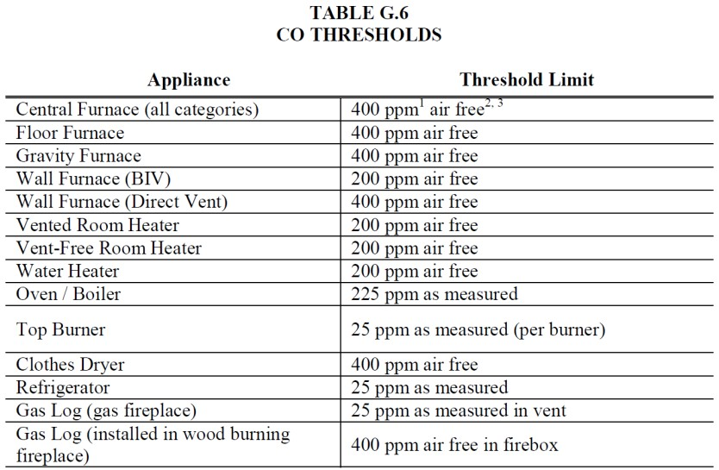

Safety & Risk Management Best Practices
The Program encourages Participating Contractors to have procedures in place for field safety and risk management protocols. Below is a list of field safety procedures that may involve the installation of a direct install measure. This list is not meant to be all-encompassing.

Broken Bulb Extraction – Safety and Removal Process
Follow when a bulb breaks while still partially or fully screwed into the socket.
During the direct installation process employees may come across incandescent bulbs that have separated from the bulb base, where the bulb base piece remains lodged inside the fixture. In these instances, the broken bulb extraction safety and removal procedures should be followed.
Broken bulb extraction safety procedure: Once the need for broken bulb extraction safety procedure has been identified, the luminaire must be powered down at the switch by placing the switch in the “off” position. A current testing device should be used to test the luminaire sockets to assure the luminaire has been powered-down.

- If the luminaire is identified as powered-down, the employee may proceed with the removal of the incandescent bulb base piece from the fixture.
- If the luminaire has not powered-down after the switch has been placed in the “off” position and current is still present during testing, then proper lockout procedure at the breaker box/service panel should be followed.

Broken bulb extraction: Once the fixture has been identified as powered-down, an approved broken bulb extraction tool may be used to remove the broken incandescent bulb base that is lodged inside the fixture. To remove the broken piece, insert the broken bulb extraction tool into the broken piece and apply minimal pressure. (Make sure to wear the proper safety gloves and safety glasses while performing this task). If possible, the other hand should grasp the base of the fixture that contains the broken piece. While applying pressure and turning the broken bulb extractor in a counter-clock wise direction, the other hand should firmly grasp the fixture base to prevent it from turning in the same direction as the broken piece. Not following this step may result in a loosening/fracturing of the wires that are connected/soldered to the back side of the fixture base piece. Once removed, the broken piece should be properly discarded. Make sure to restore power to the fixture to assure proper “test-out” of the fixture and newly installed bulb.

Clean-Up Procedure: Broken LEDs and Incandescent Bulbs
Follow for LED or incandescent bulb breaks. NOTE – this is a different procedure than for broken CFLs.
LEDs may contain dangerous chemicals such as lead and arsenic. The procedure for cleaning up broken LEDs differs from the procedure for cleaning up broken CFLs because the chemicals found within LEDs are not discharged into the breathable air when the LED breaks. The chemicals are components of the solid pieces that make up the LED. CFLs contain mercury which can be released into the breathable air immediately upon breakage. Therefore, CFLs pose a greater immediate hazard risk than LEDs.
Items needed for broken LED or incandescent bulb clean-up:
- Safety gloves
- Safety glasses
- Hand broom
- Dustpan
- 2 small trash or sandwich bags
- Duct tape
- Vacuum cleaner with hose attachment Clean-Up Procedure:
- Don the safety gloves and safety glasses, to protect your hands and eyes from glass or plastic shards, prior to beginning the clean-up process.
- Prepare the trash bags by placing one inside the other. Double bagging can prevent shards from poking though. You may also use plastic sandwich bags for small clean-ups.
- Sweep up larger shards using a hand broom and dustpan. Dump the shards and metal components into the trash or sandwich bags.
- Tear off a strip of duct tape about 6” long. Press the adhesive side slightly to the surface where the bulb broke. This will pick up small pieces of glass that the broom left behind. Once done, place the duct tape into the plastic bag and seal or tie the bag closed.
- If available, use a hose attachment on a vacuum cleaner to suck up the rest of the bulb particles. DO NOT USE a vacuum cleaner that belongs to a Participant; the vacuum should be a tool of the assessment or installing company.
- NOTE: This may not be a necessary step if the bulb broke on a hard surface. It is recommended to perform this step if the bulb broke over a carpeted area. If the bulb broke over a carpeted area, you may eliminate step 3 above as a dustpan will not be effective on carpet.
- Properly dispose of the bagged-up pieces.

Loose Fixture Identification Procedure
Follow to test fixtures prior to replacing the bulbs.
During the direct installation process employees may come across lighting fixtures that are loose or poorly secured to a ceiling or wall. In these instances, the Participant should be made aware of the issue and the installation should not proceed. If the Participant can properly secure the fixture to the ceiling or wall during the visit then the installation may proceed, if the installer feels safe moving forward with the installation.

Clean Up Procedure: Mercury in Thermostats
Follow to clean mercury spills from thermostats.

Items needed for small spill mercury clean-up:
- 4-5 Ziploc-type bags
- Trash bags
- Rubber, nitrile or latex gloves
- Paper towels
- Cardboard or squeegee
- Eyedropper
- Duct tape or shaving cream and small paint brush
- Flashlight

Clean-Up Procedure:
- Put on rubber, nitrile, or latex gloves.
- If there are any broken pieces of glass or sharp objects, pick them up with care. Place all broken objects on a paper towel. Fold the paper towel and place in a zip lock bag. Secure the bag and label it as directed by your local health or fire department. Follow the “Mercury Recycling Procedure” for properly recycling the liquid mercury.
- Locate visible mercury beads. Use a squeegee or cardboard to gather mercury beads. Use
- slow sweeping motions to keep mercury from becoming uncontrollable. Take a flashlight, hold it at a low angle close to the floor in a darkened room and look for additional glistening beads of mercury that may be sticking to the surface or in small cracked areas of the surface.
- Note: Mercury can move surprising distances on hard-flat surfaces, so be sure to inspect the
entire room when “searching.”
- Use the eyedropper to collect or draw up the mercury beads. Slowly and carefully squeeze mercury onto a damp paper towel. Place the paper towel in a zip lock bag and secure. Make sure to label the bag as directed by your local health or fire department.
- After you remove larger beads, put shaving cream on top of small paint brush and gently “dot” the affected area to pick up smaller hard-to-see beads. Alternatively, use duct tape to collect smaller hard-to-see beads. Place the paint brush or duct tape in a zip lock bag and secure. Make sure to label the bag as directed by your local health or fire department.
- Remember to keep the area well ventilated to the outside (i.e., windows open and fans in exterior windows running) for at least 24 hours after your successful cleanup. Continue to keep pets and children out of cleanup area. If sickness occurs, seek medical attention immediately. View information on health effects related to exposures to vapors from metallic mercury. For additional information on health effects, the Agency for Toxic Substances and Disease Registry (ATSDR) provides a Mercury Fact Sheet that also presents information on health effects related to exposures to vapors from metallic mercury.

Mercury Recycling and Handling Procedure – Thermostats
Follow when products containing mercury are removed from an interested Participant site.
Mercury-containing thermostats that are removed should be taken from the home and properly recycled, adhering to local and state laws as applicable.
The following steps should be taken to handle, transport, and recycle mercury thermostats:
- Each existing mercury containing thermostats must be placed inside their own separate Ziploc bag and sealed/zipped closed.
- They should then be placed inside a designated plastic bin inside the work van.
- Once the shift has ended all mercury containing thermostats must be removed from the plastic bag and placed into an approved recycling receptacle. (Visit http://www.thermostat-recycle.org/ for information on mercury recycling bins.)
  - Franklin Energy’s office at 23 Copper Drive is an available drop off location for
Participating Contractors.
- Only the piece that is attached to the mercury ampule should go inside the recycling bin per instructions provided by the Thermostat Recycling Corporation.
- All other pieces should be properly disposed of in the garbage.
- Instructions for proper contents and disposal should be clearly posted near the recycling bins.
- If for some reason the mercury recycling bin is not available, then the mercury containing thermostat(s) must remain inside the Ziploc bag and inside the plastic storage bin until the first opportunity to recycle the materials arises. Such products should not remain inside a work vehicle for more than 48 hours.

